**Name:** Divyansh Kumbhat

**Branch & Year: CSE**(AIML)**, First Yr.**

**Section: G**1

**Practical 3**

**Aim:** Design an informative Tourism Website stating the Attraction of the Nagpur City with the help of HTML programming and along with it using the different ways of CSS Style behavior in it.

**Code:**

**HOME PAGE:**

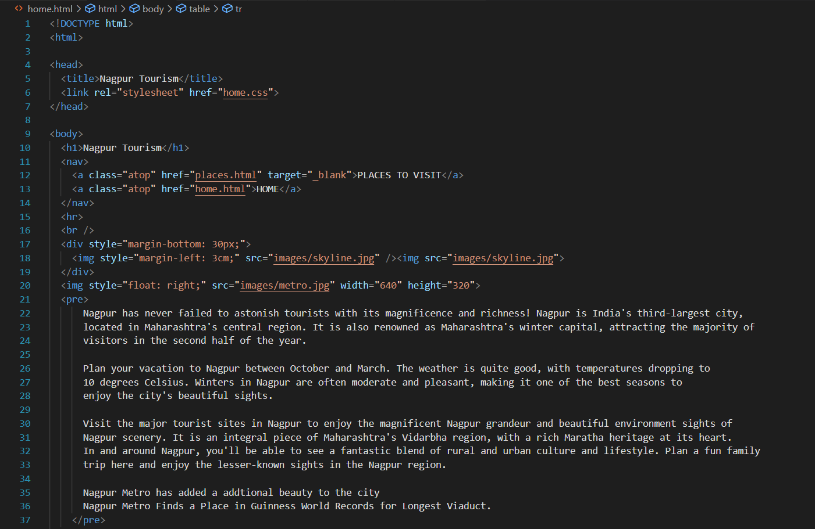

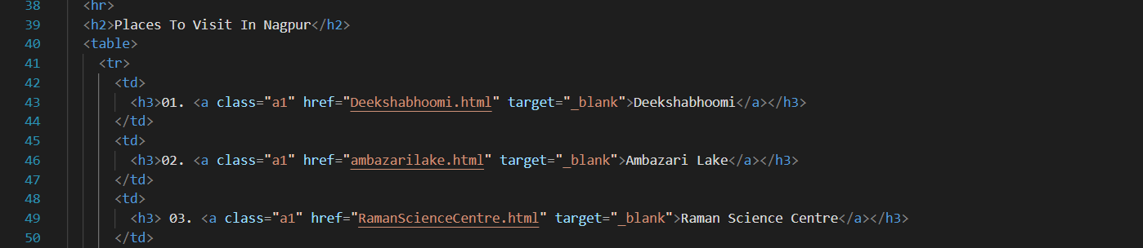

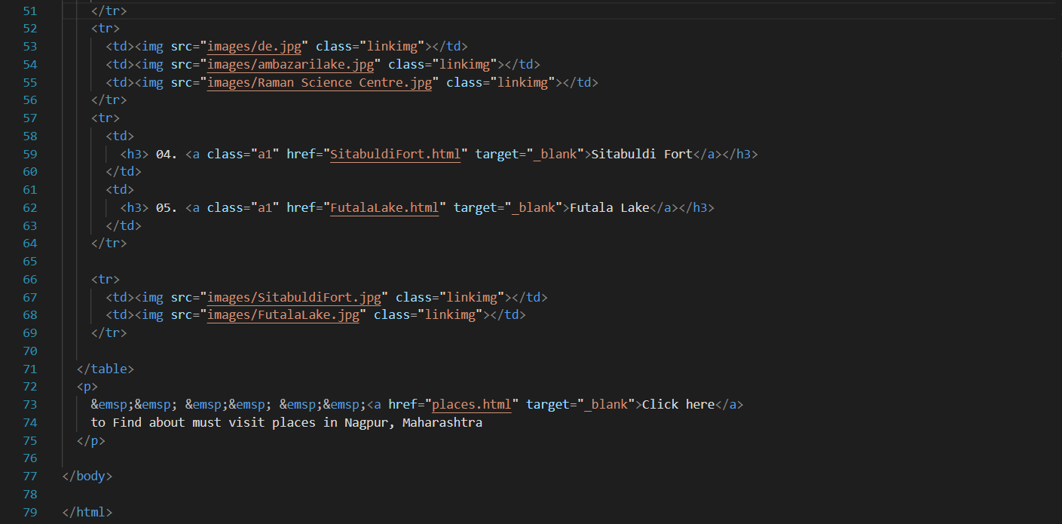

[**Deekshabhoomi**](http://127.0.0.1:5500/Deekshabhoomi.html)**:**

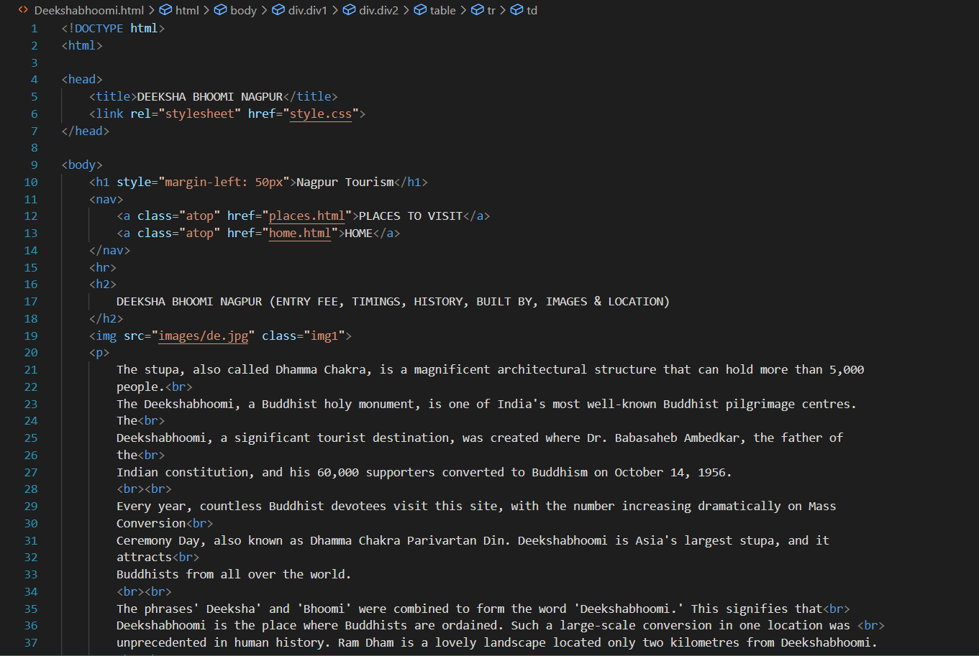

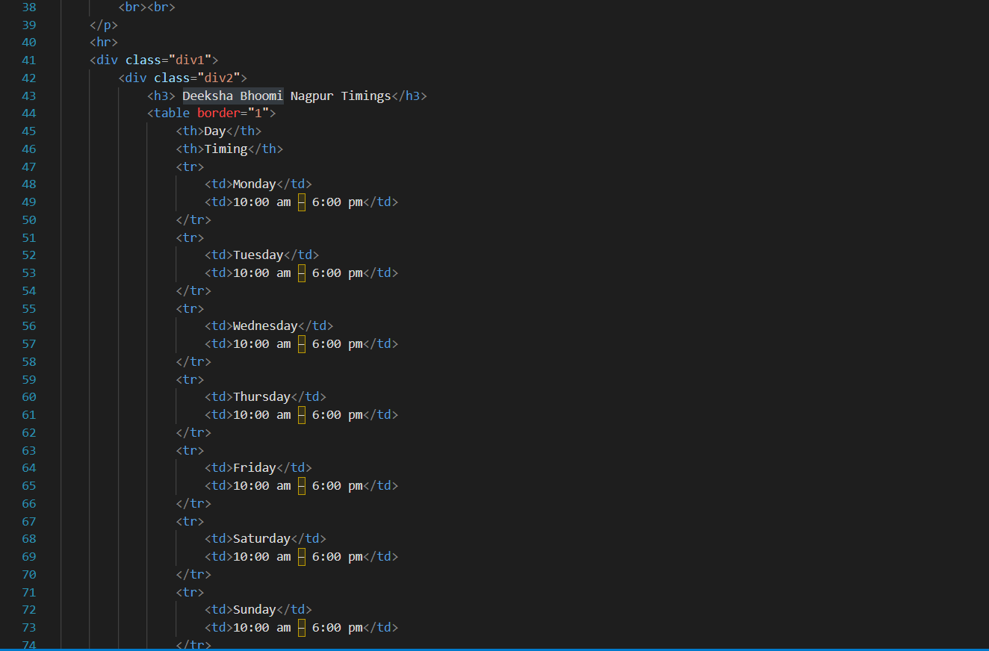 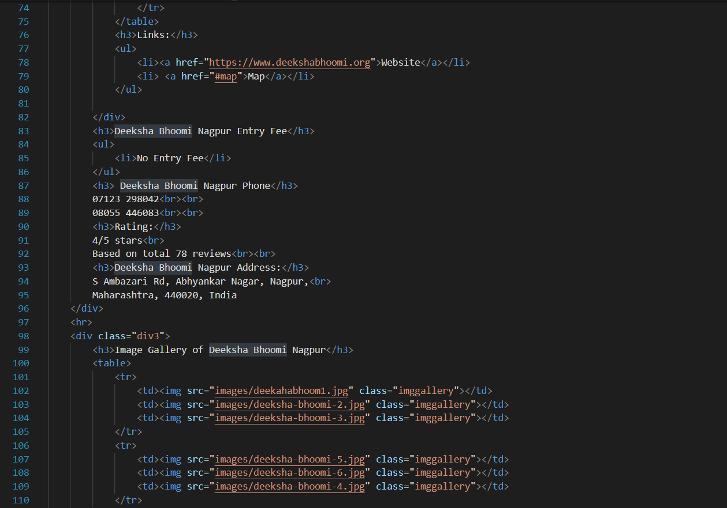

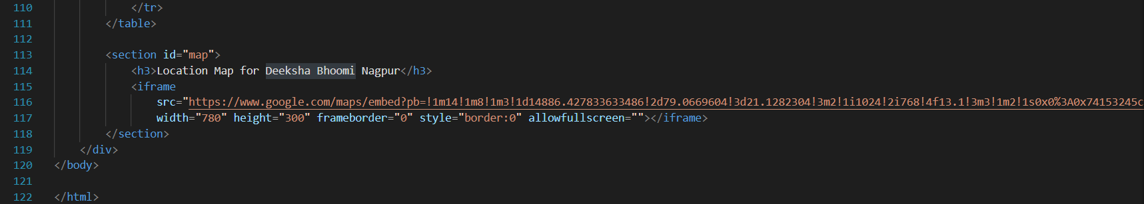

[**Ambazari** **Lake**](http://127.0.0.1:5500/ambazarilake.html)

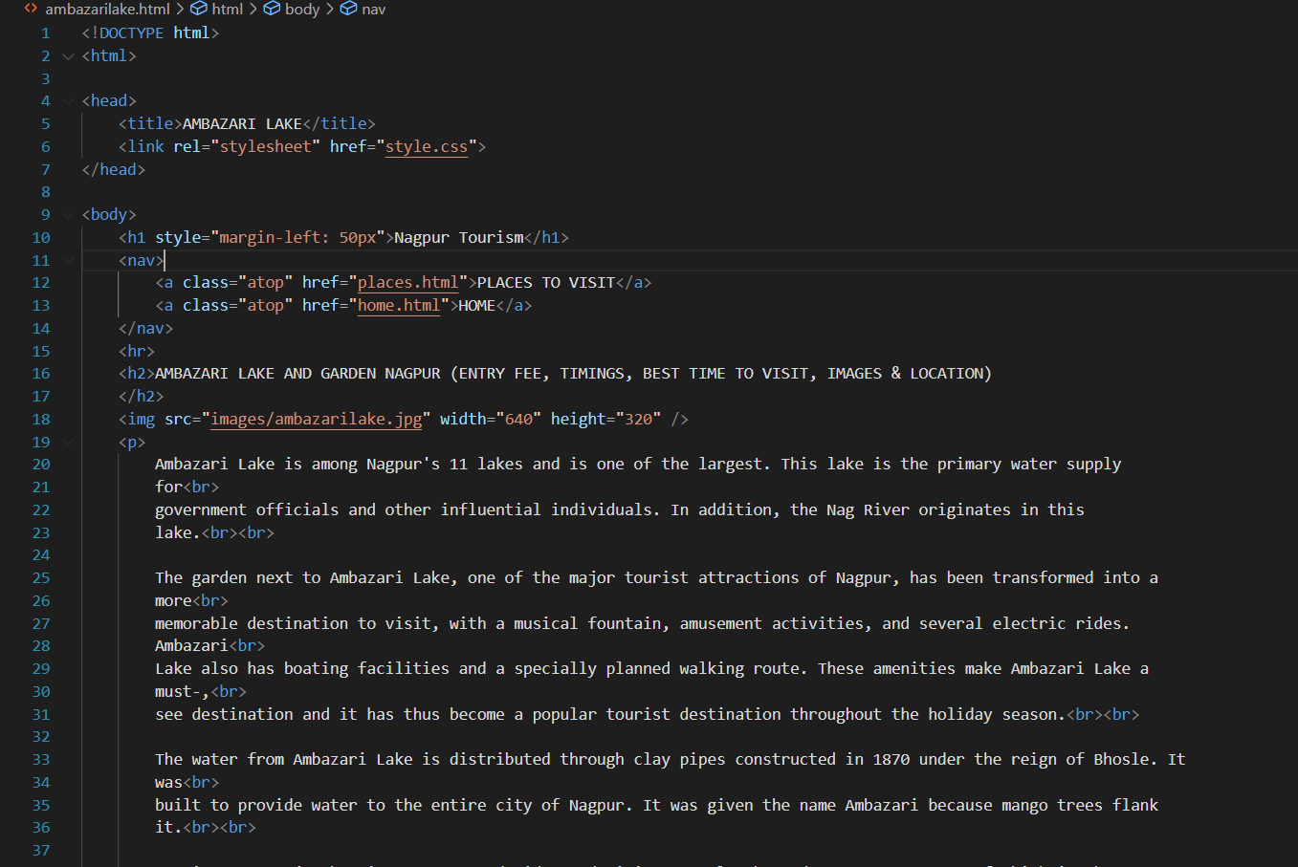

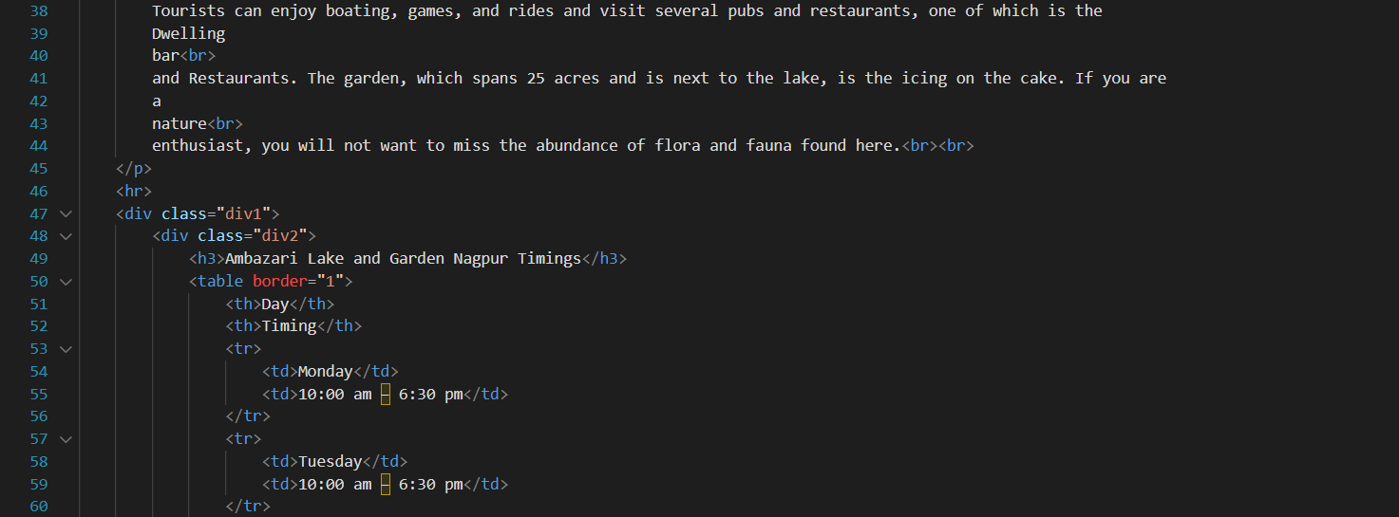

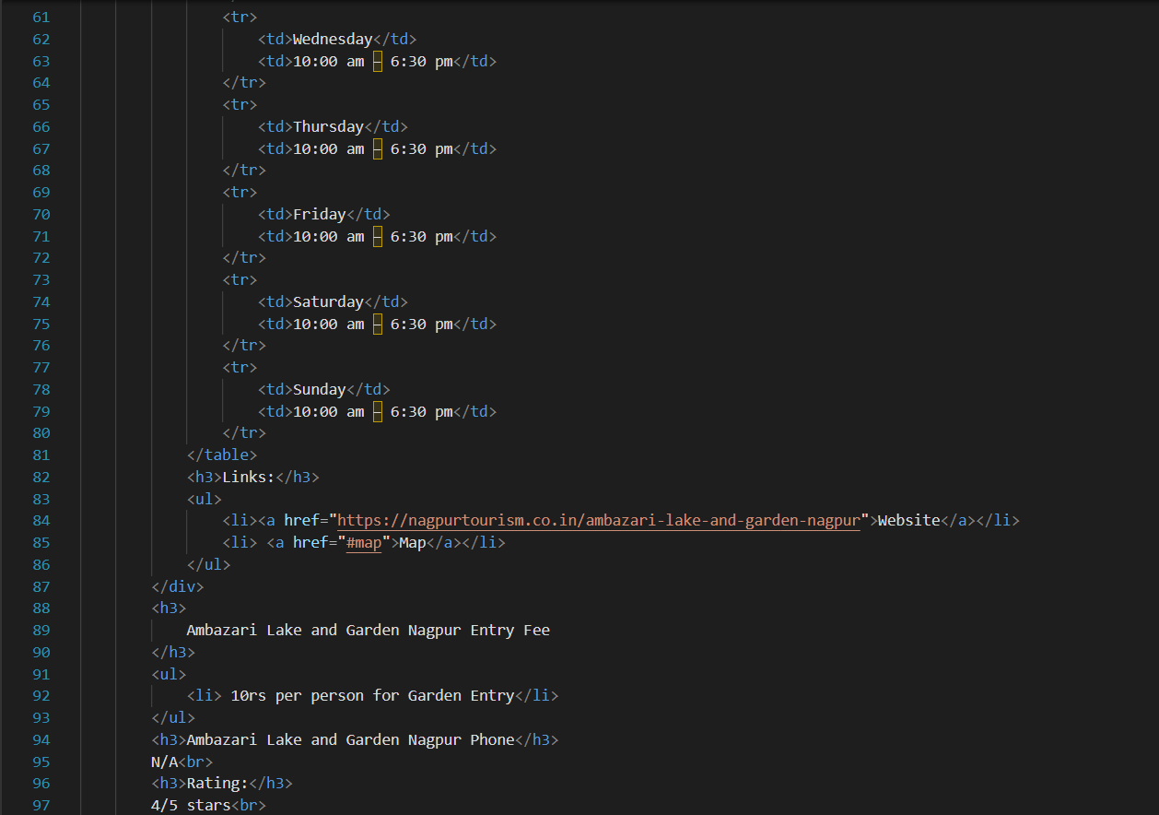 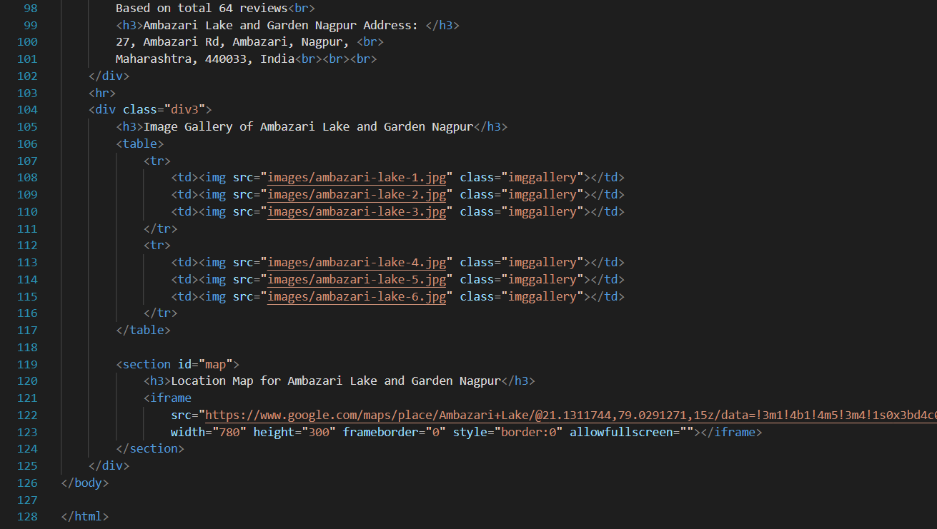

[**Raman** **Science** **Centre**](http://127.0.0.1:5500/RamanScienceCentre.html)**:**

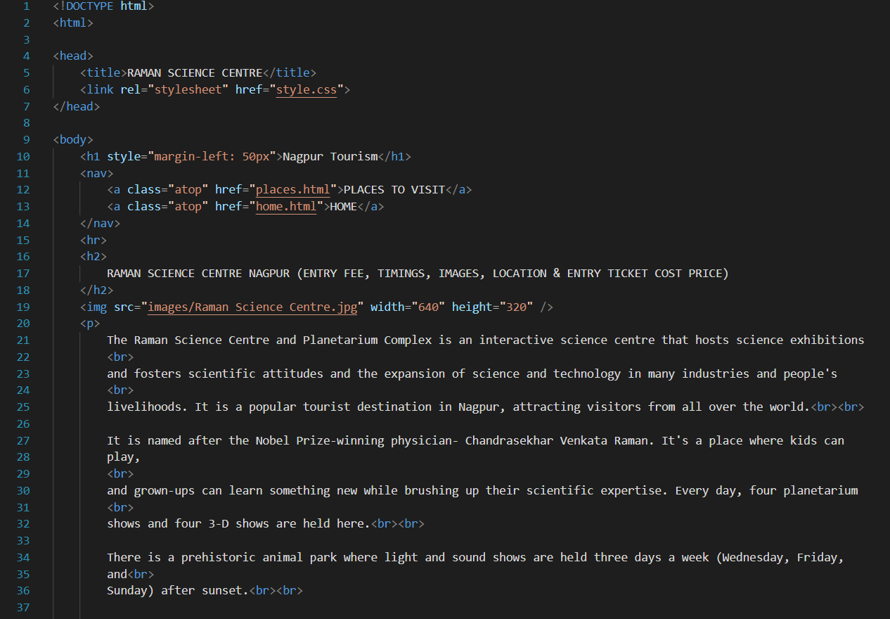 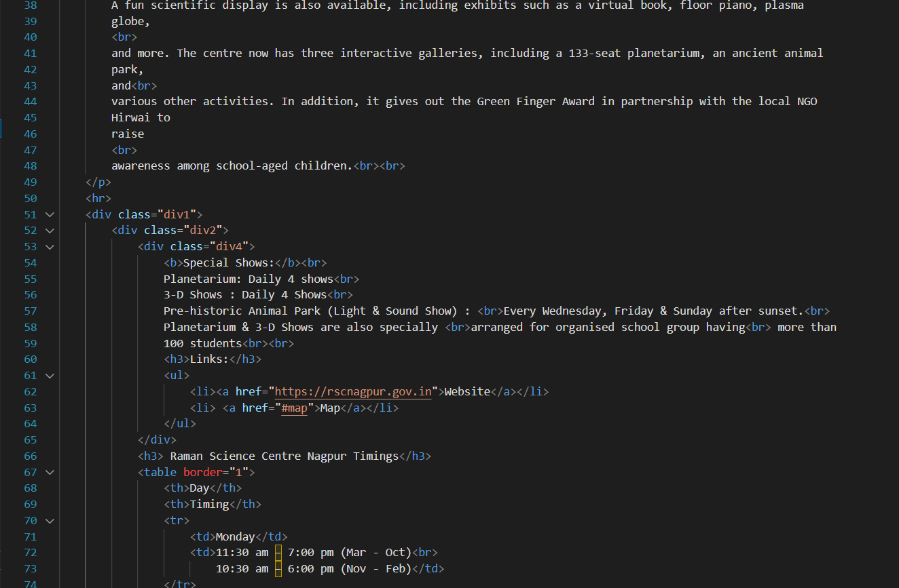 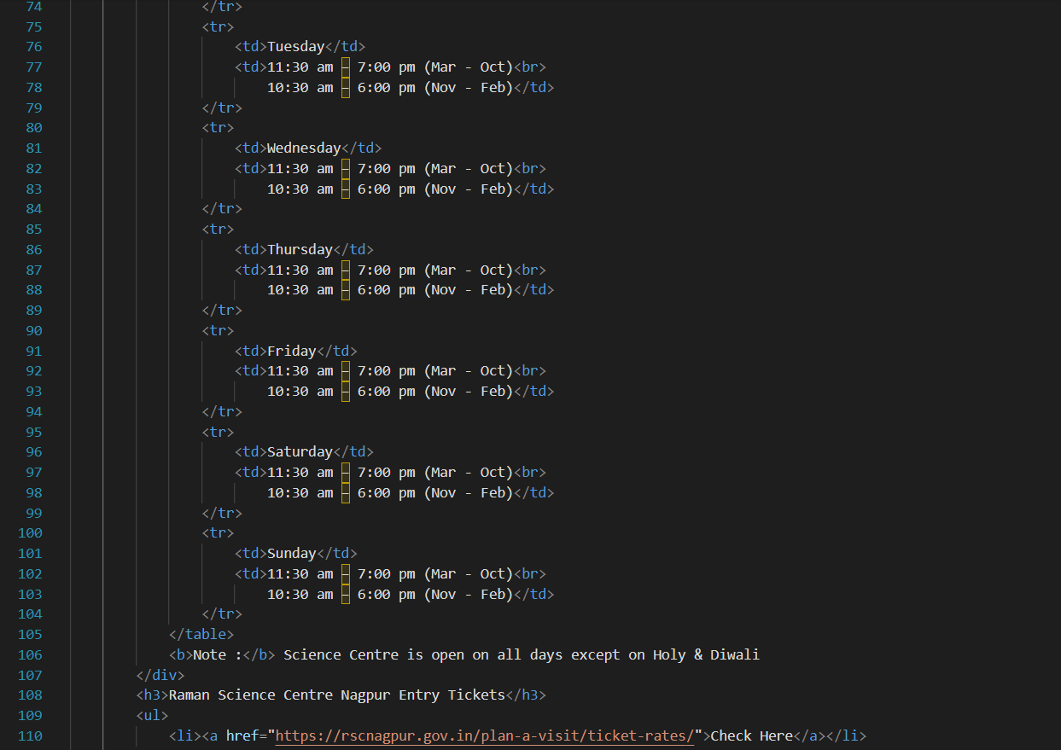 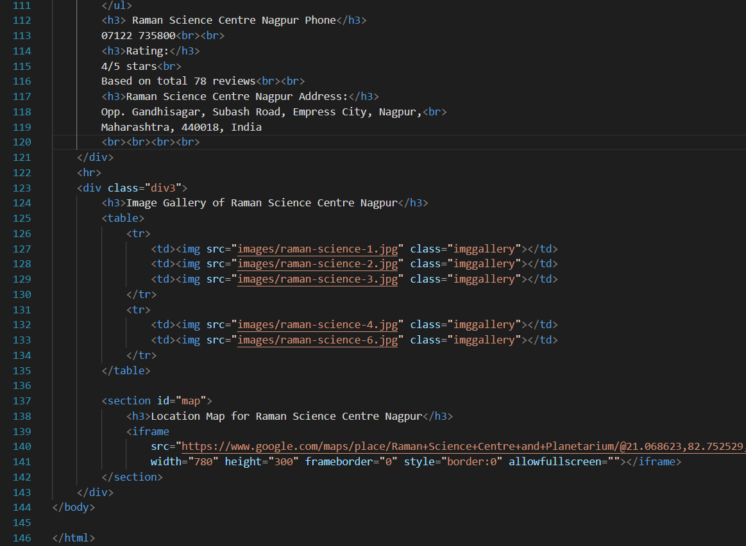

[**Sitabuldi** **Fort**](http://127.0.0.1:5500/SitabuldiFort.html)**:**

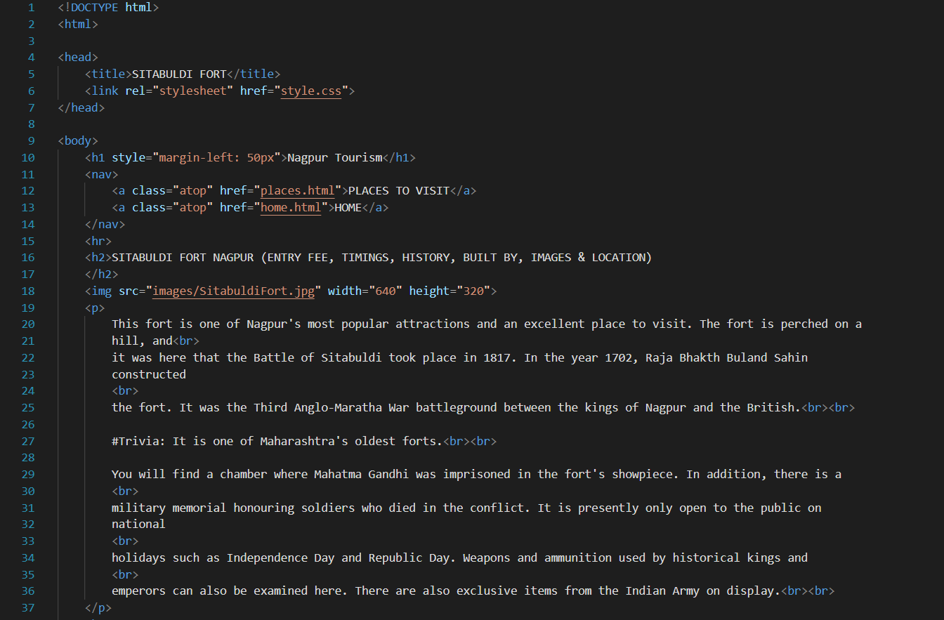 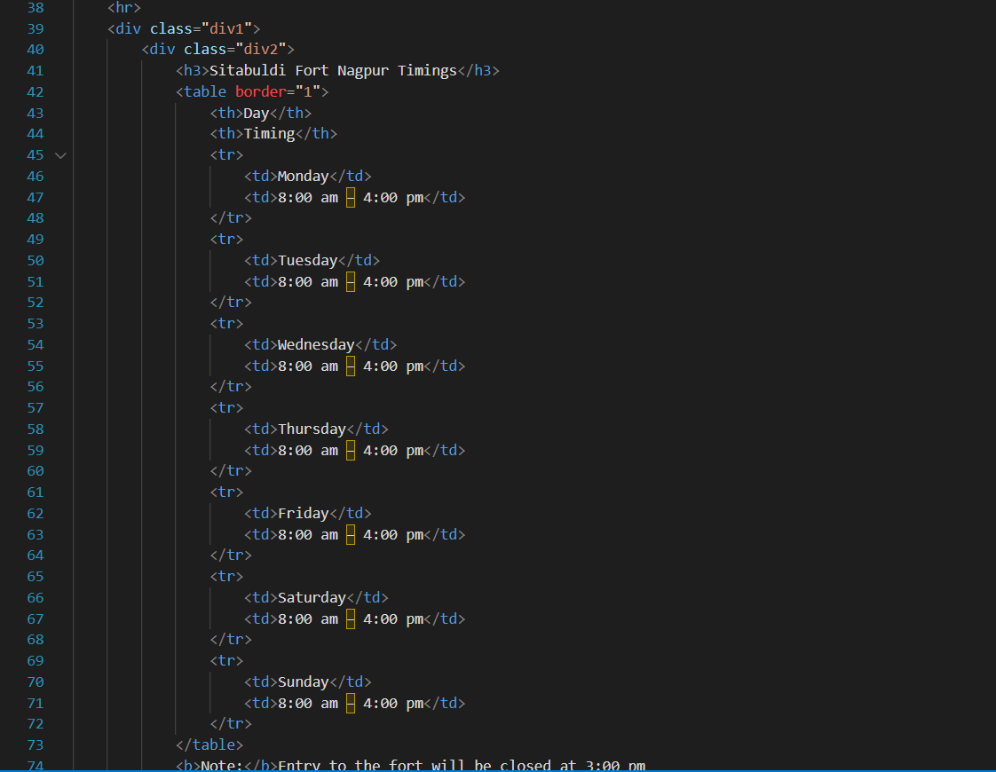

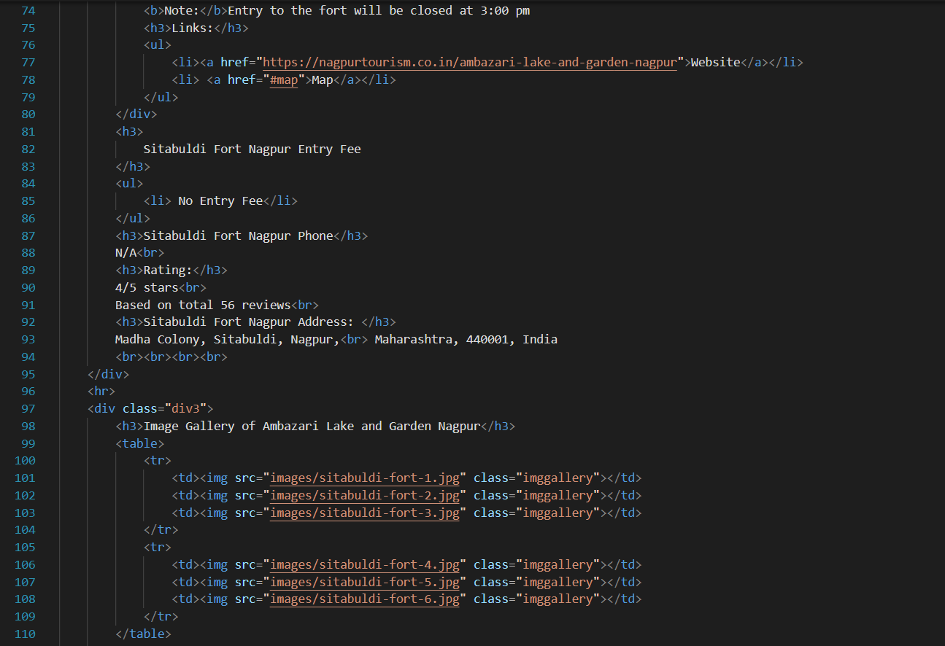 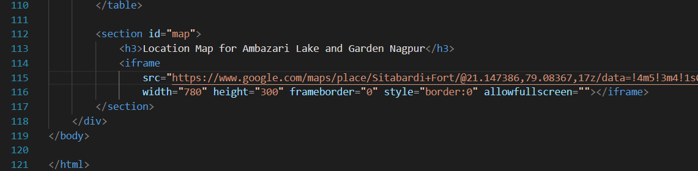

[**Futala** **Lake**](http://127.0.0.1:5500/FutalaLake.html)

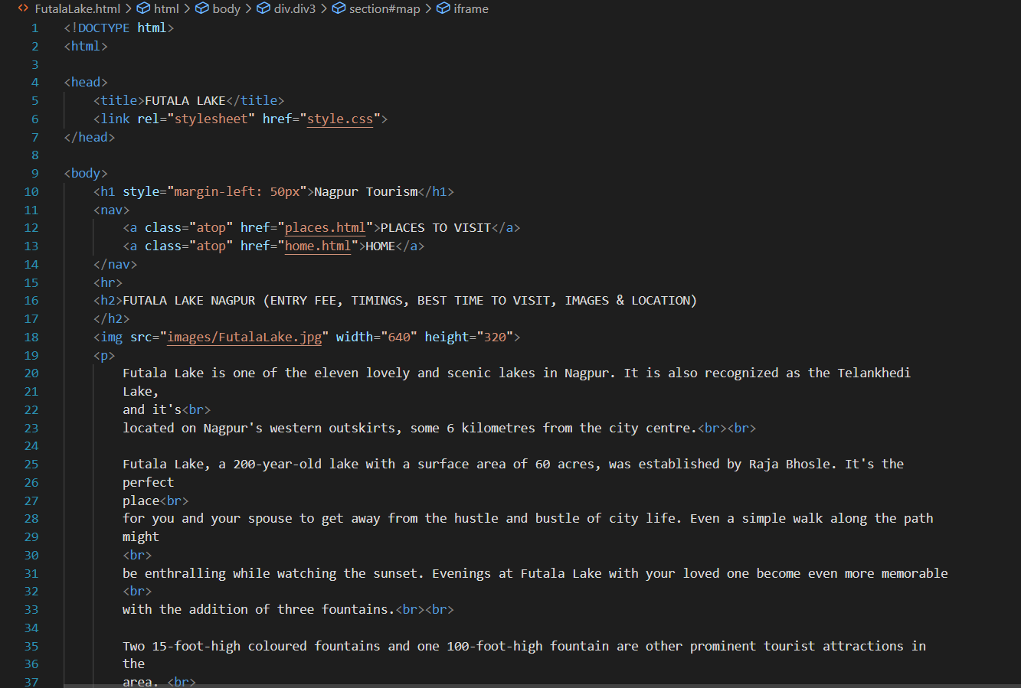 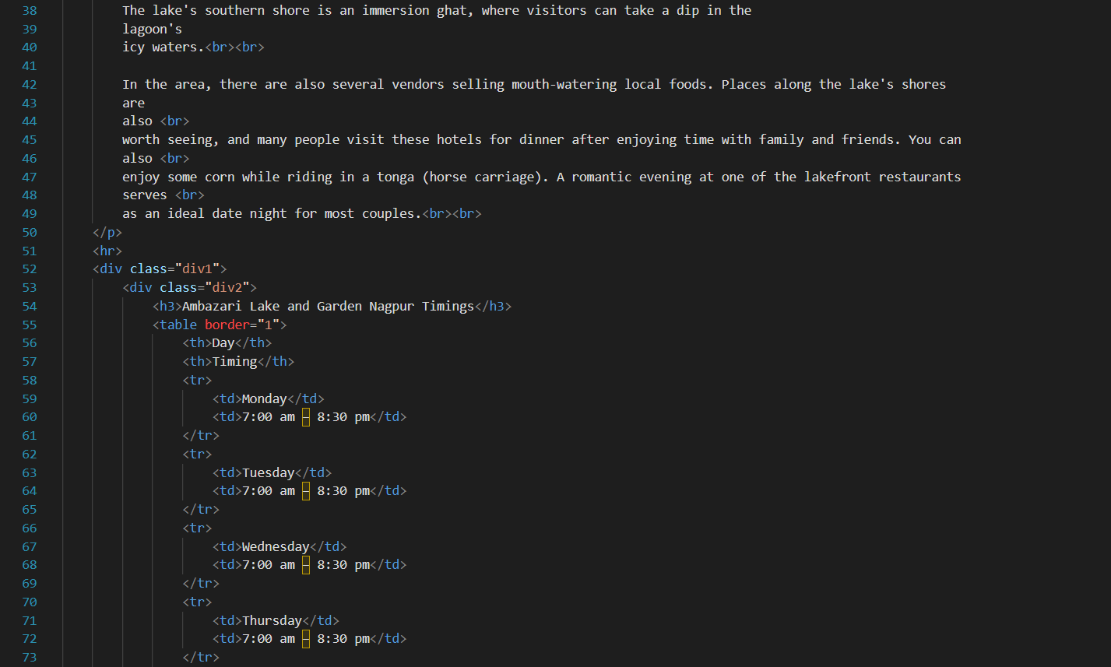 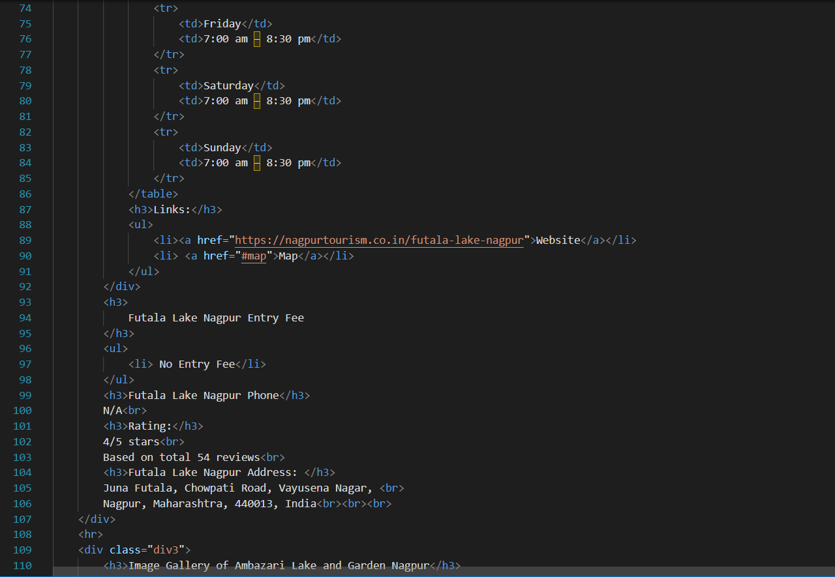 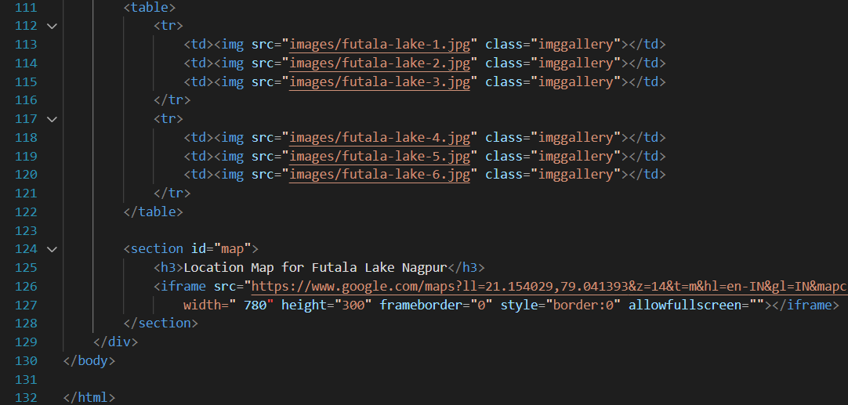

**HOME PAGE CSS File**

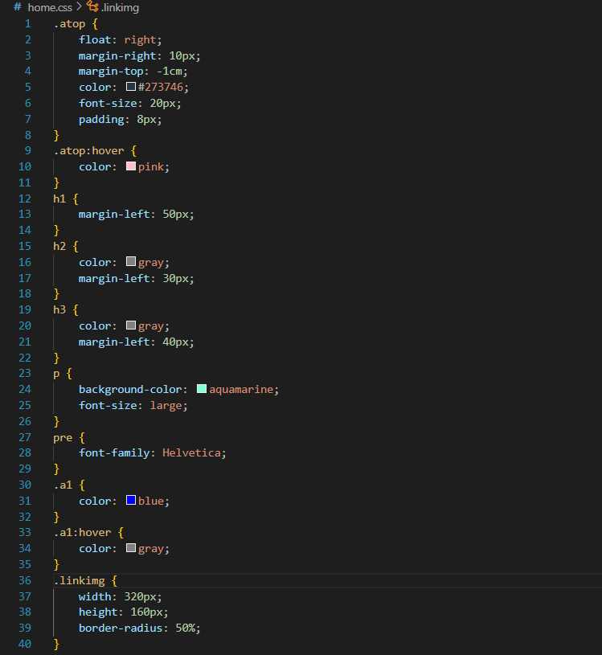

**OTHER PAGES CSS File**

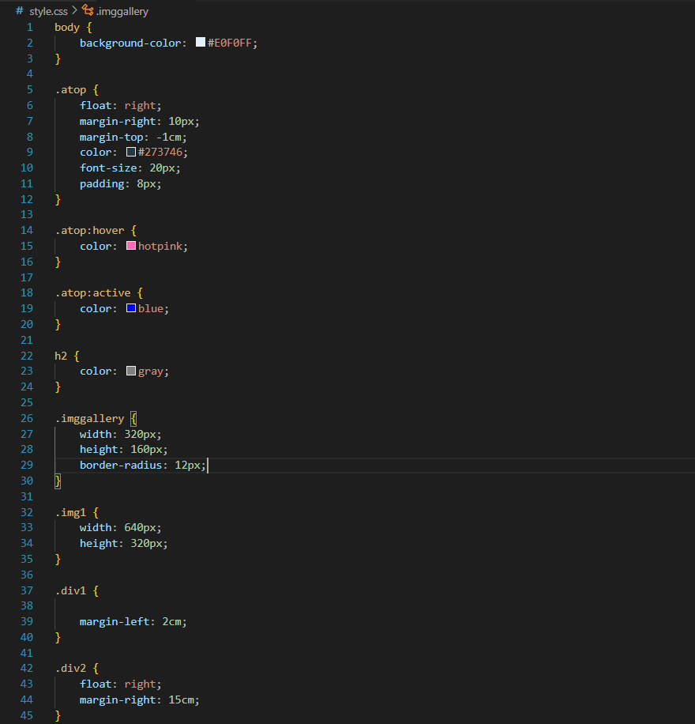 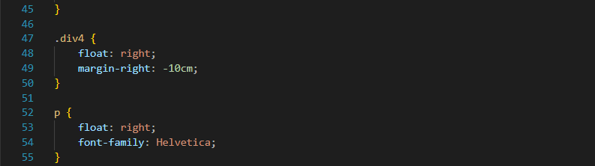

**Screenshot Output:**

**HOME PAGE**

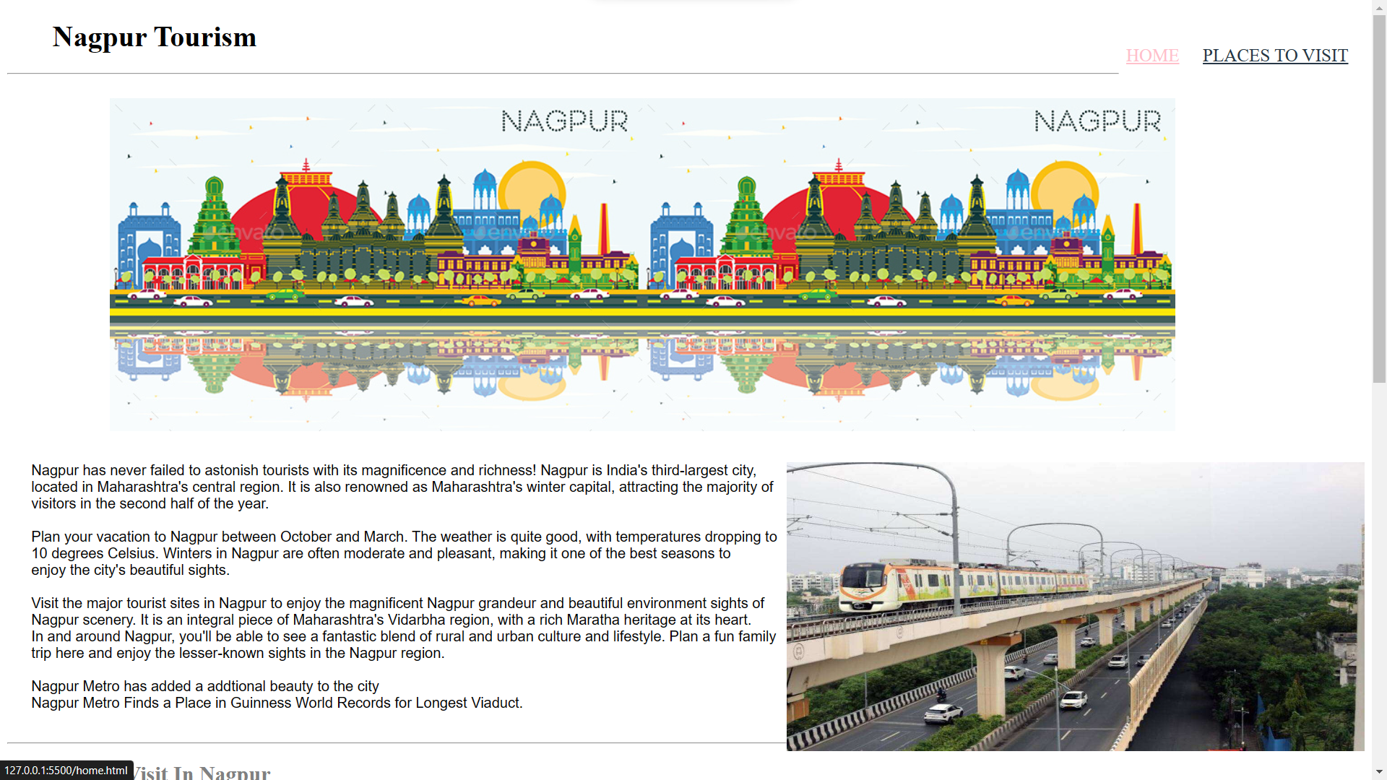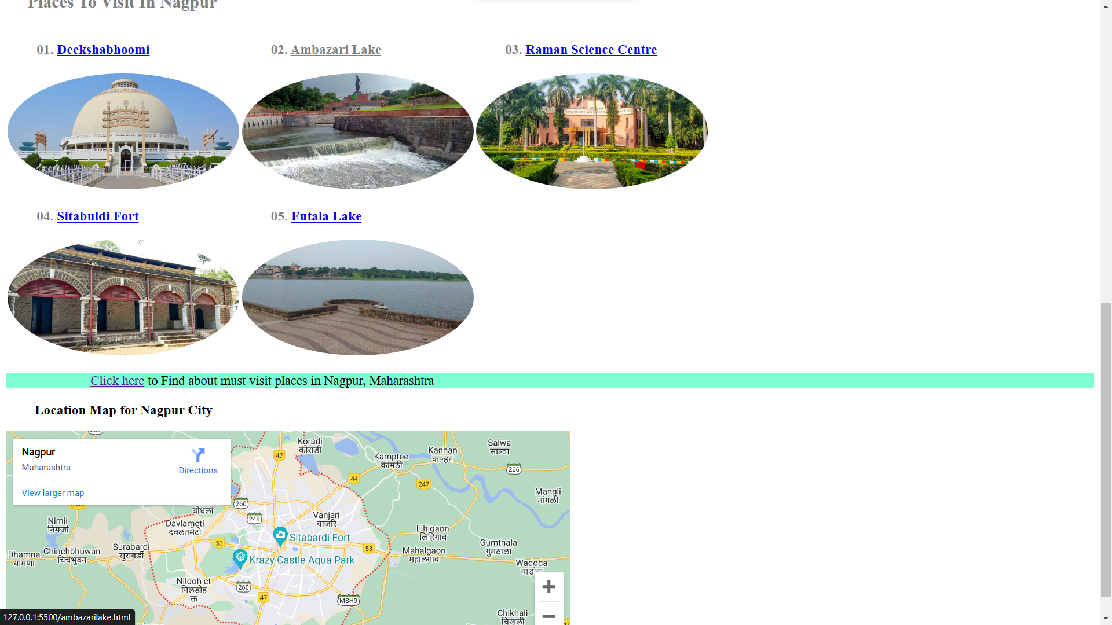

**Deeksha Bhoomi**

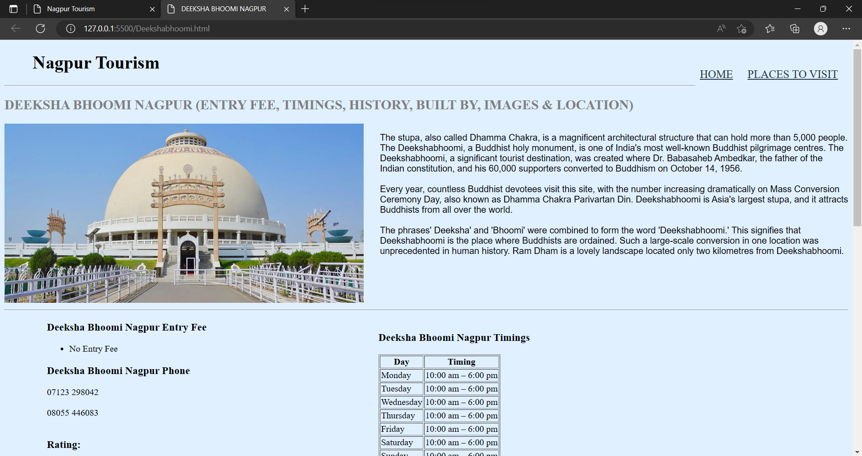 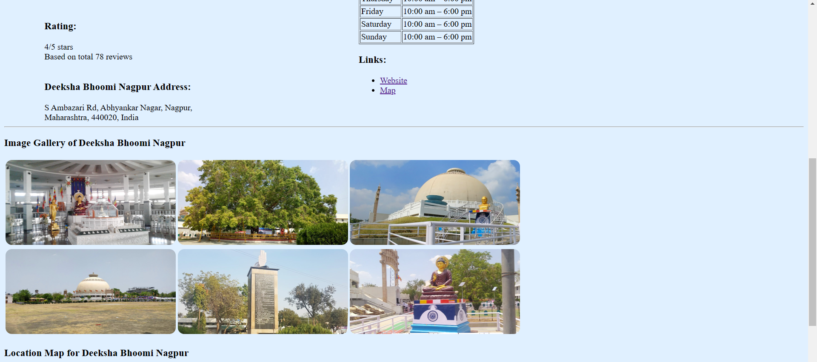 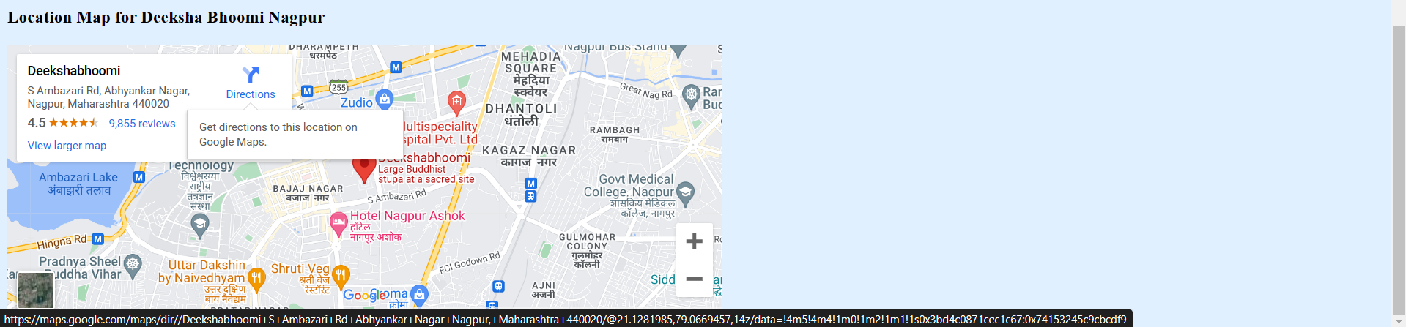

**Ambazari Lake**

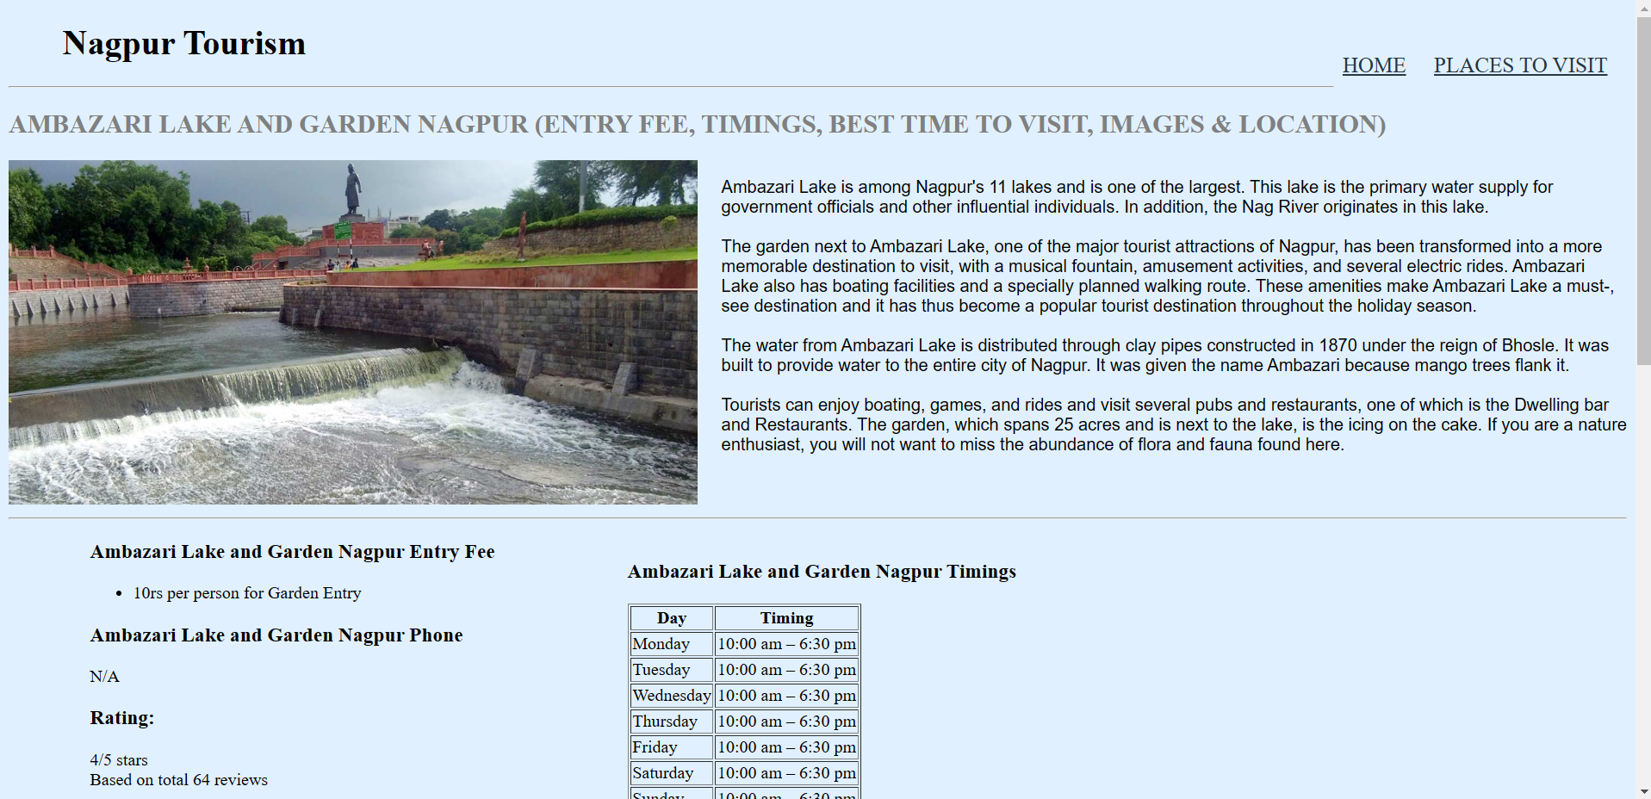

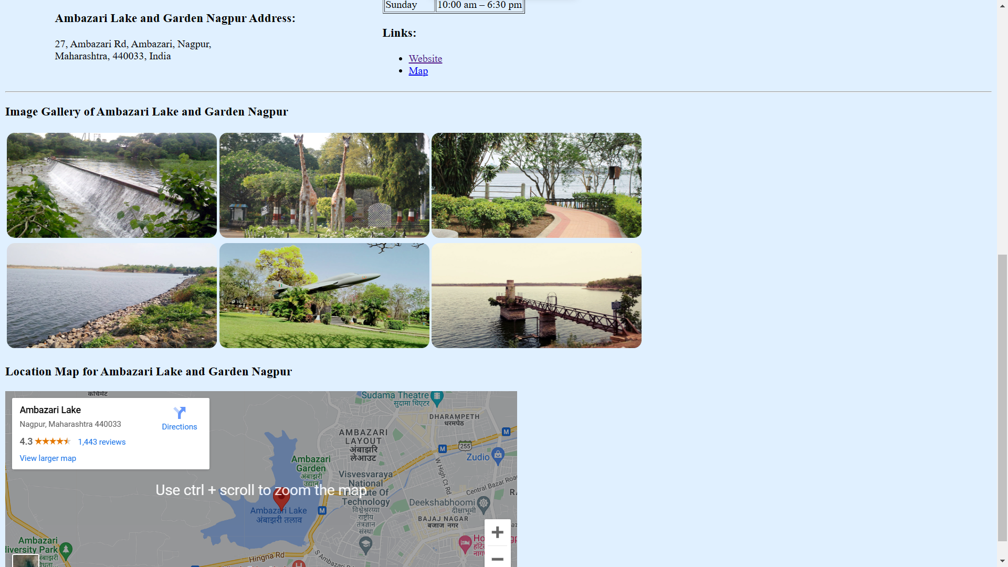

**Raman Science Centre**

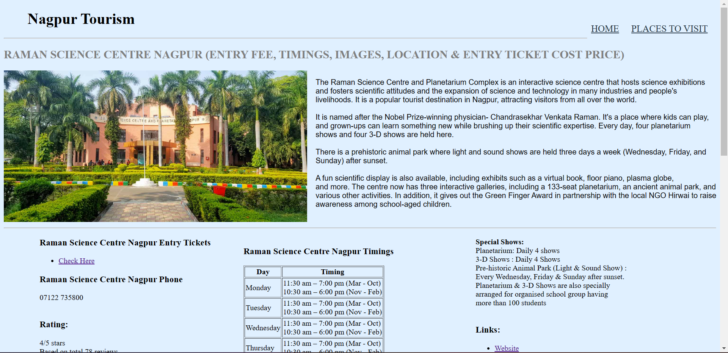 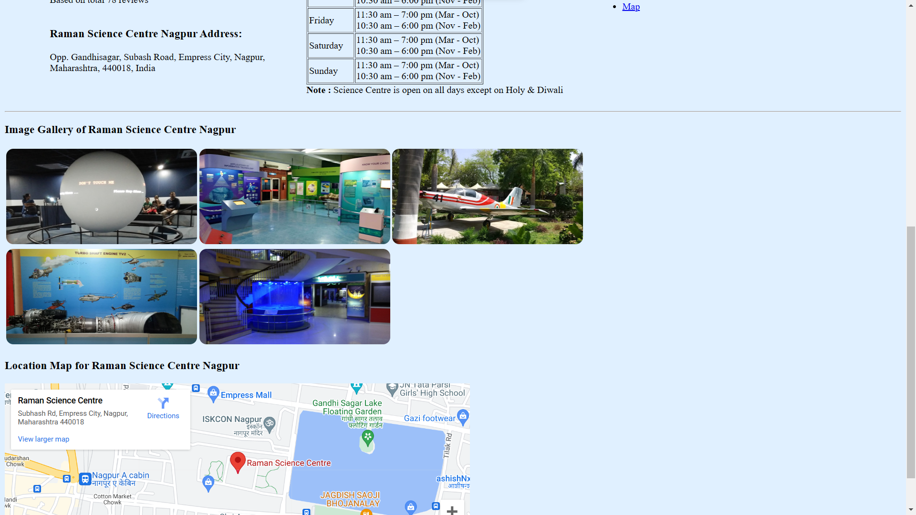

**Sitabuldi Fort**

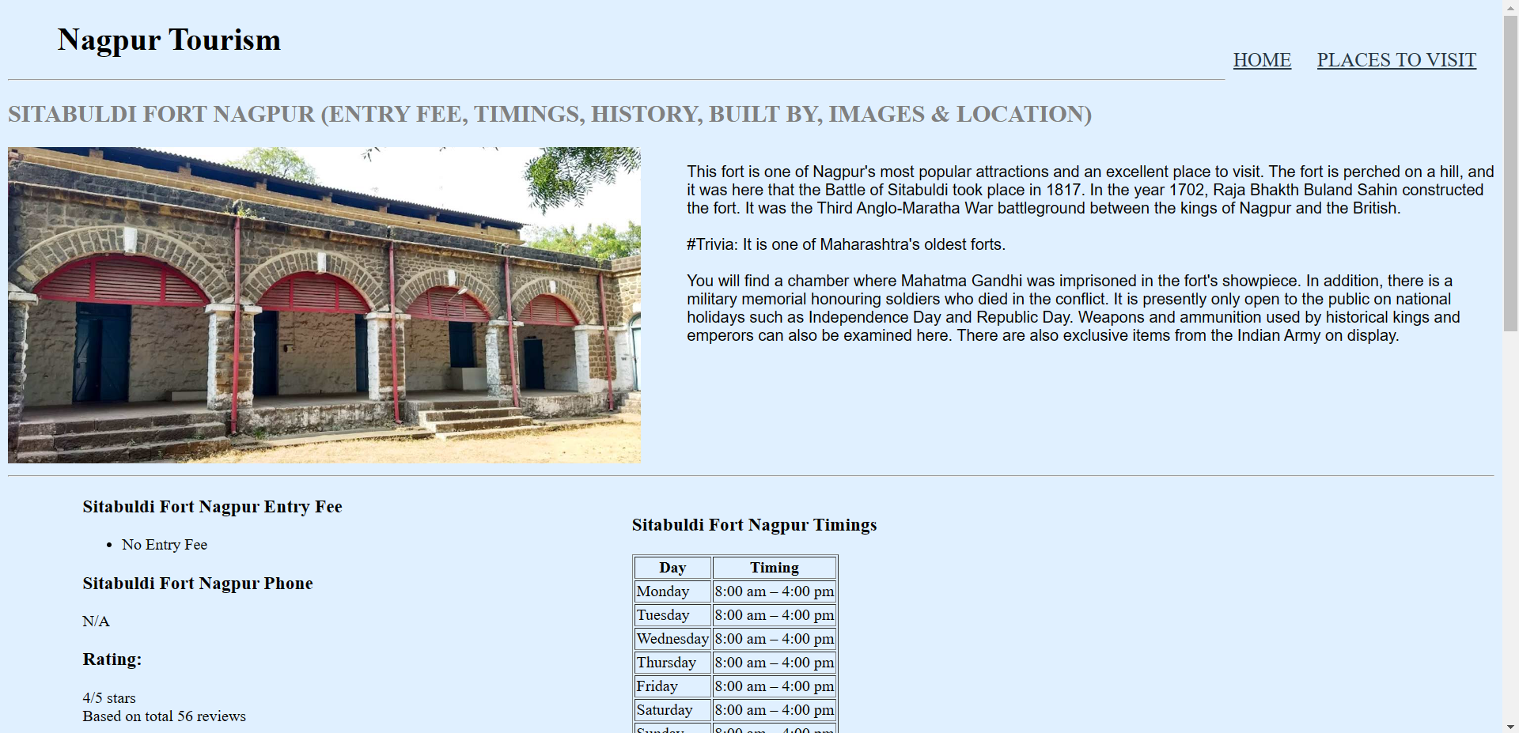 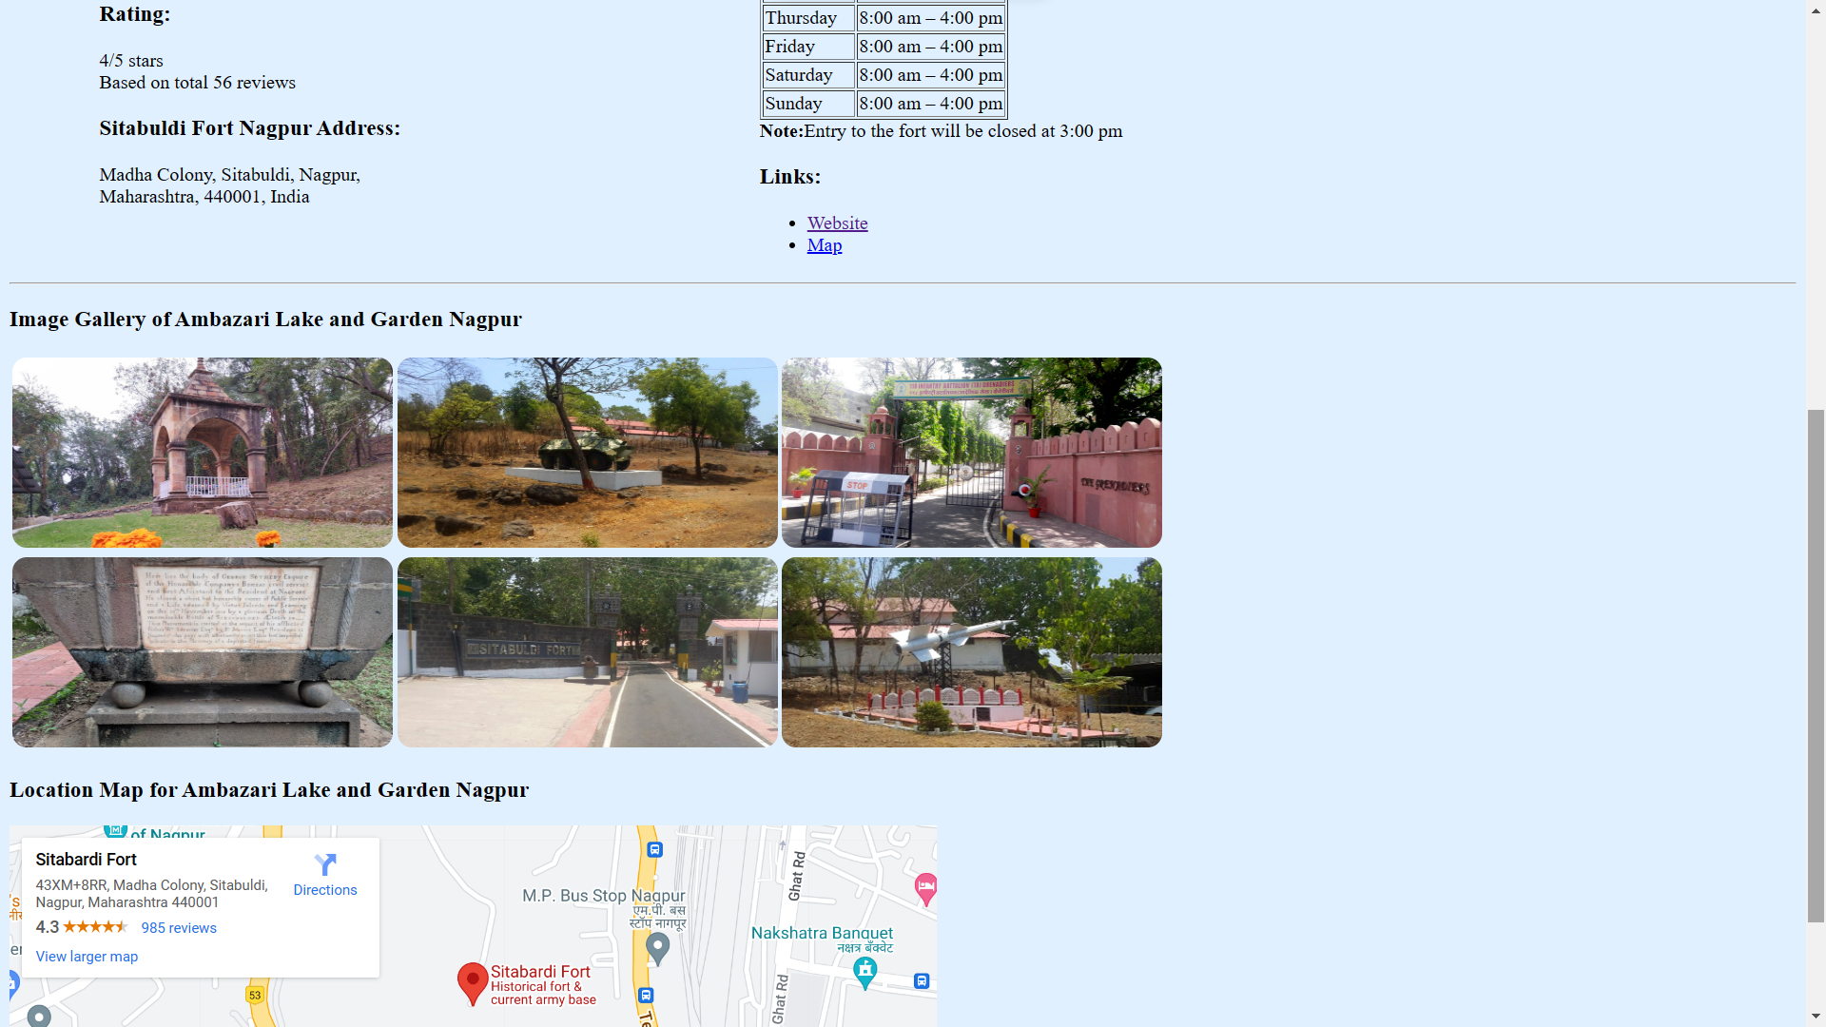

**Futala Lake**

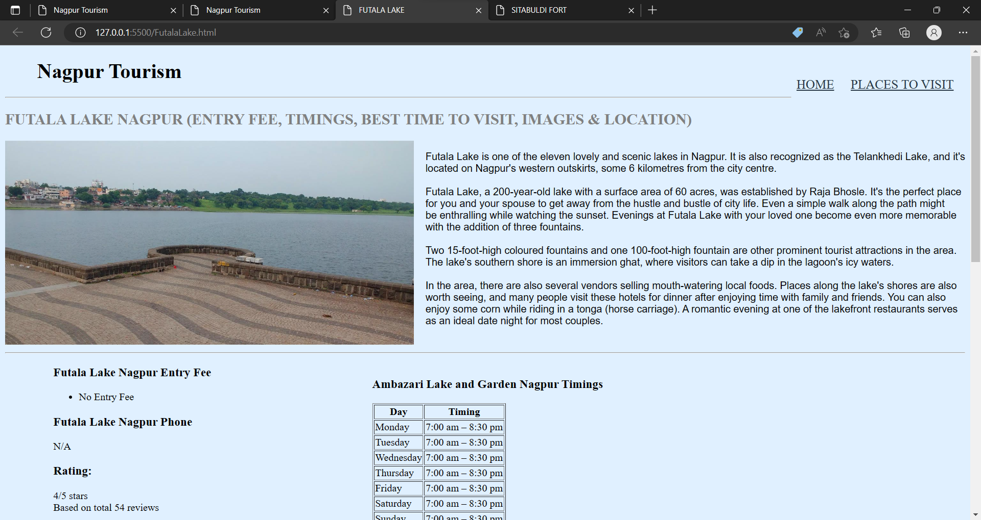 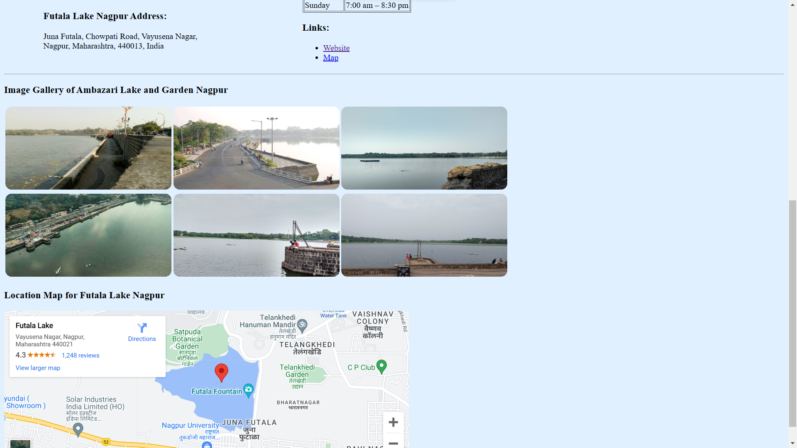

**Conclusion:** we were able to Design an informative Tourism Website stating the Attraction of the Nagpur City with the help of HTML programming and along with it using the different ways of CSS Style behavior in it.